

A PROJECT REPORT ON

STATISTICAL ANALYSIS AND PREDICTION OF STUDENT ACADEMIC PERFORMANCE

SUBMITTED TO SANT GADGE BABA AMRAVATI UNIVERSITY, AMRAVATI IN PARTIAL FULFILLMENT OF THE REQUIREMENTS FOR THE AWARD OF THE DEGREE

BACHELOR OF ENGINEERING (INFORMATION AND TECHNOLOGY)

BY

Siddhant Dongre Samruddhi Mankar Shruti Dahibhat Vaibhavi Chavan Sakshi Ubale

Under the guidance of Dr.P.M.Hasabnis

Department of Information and Technology

Late Purushottam Hari (Ganesh) Patil Shikshan Sanstha’s
Mauli Group of Institution’s,
College of Engineering & Technology, Shegaon-444203 Session 2024-25

Department of Information and Technology
Late Purushottam Hari (Ganesh) Patil Shikshan Sanstha’s
Mauli Group of Institution’s,
College of Engineering & Technology, Shegaon-444203

CERTIFICATE

This is to certify that, the dissertation report entitled

“STATISTICAL ANALYSIS AND PREDICTION OF STUDENT ACADEMIC PERFORMANCE”

Submitted by

Siddhant Dongre Samruddhi Mankar Shruti Dahibhat Vaibhavi Chavan Sakshi Ubale
are bonafide work carried out by them under the supervision of Dr.P.M.Hasabnis and it is submitted towards the partial fulfillment of the requirement of Sant Gadge Baba Amravati University, Amravati for the award of the degree of Bachelor of Engineering (Information and Technology) .

Prof.\Dr. P. M. Hasabnis Prof.\Dr. P. M. Hasabnis
Internal Guide Head
Dept. of Information and Technology Dept. of Information and Technology

Seal/Stamp of the College

Place:Shegaon Date:

Dr. C. M. Jadhao Principal,
MGI-COET,
Shegaon.

PROJECT APPROVAL SHEET

Project Entitled

“STATISTICAL ANALYSIS AND PREDICTION OF STUDENT ACADEMIC PERFORMANCE ”
By
Siddhant Dongre Samruddhi Mankar Shruti Dahibhat Vaibhavi Chavan Sakshi Ubale

is approved for the Degree of Bachelor of Engineering in
Department of Information and Technology, of
Sant Gadge Baba Amravati University, Amravati

Internal Examiner External Examiner Name: Name:
Date: Date:

DECLARATION
We hereby declare that the project entitled, STATISTICAL ANALYSIS AND PREDICTION OF STUDENT ACADEMIC PERFORMANCE was
carried out and written by us under the guidance of Dr.P.M.Hasabnis, HOD of Department of Information & Technology, Mauli Group of Institution's, College of Engineering & Technology, Shegaon. This work has not been previously formed the basis for the award of any degree or diploma or certificate nor has been submitted elsewhere for the award of any degree or diploma.

Place: Shegaon Date:

Siddhant Dongre Samruddhi Mankar Shruti Dahibhat Vaibhavi Chavan Sakshi Ubale

B.E. (Third Year) Department of Information Technology
MGI-COET, Shegaon

INDEX

Sr. No. | Name of Topic |  |  | Page No.
 | ABSTRACT |  |  | 1
1 | INTRODUCTION |  |  | 2
2 | LITERATURE REVIEW |  |  | 4
3 | ANALYSIS OF PROBLEM |  |  | 7
3 | 3.1 | Current scenario |  | 8
3 | 3.2 | Solution over the problem |  | 9
3 | 3.3 | Application of system |  | 9
4 | DESIGN PROCESS |  |  | 10
4 | 4.1 | System design process |  | 11
4 | 4.2 | System flow |  | 12
5 | IMPLEMENTATION |  |  | 13
5 | 5.1 | Implementation |  | 14
5 | 5.1 | 5.1.1 | Technology used | 14
5 | 5.1 | 5.1.2 | Data and Preprocessing | 15
5 | 5.1 | 5.1.3 | Model Training and Evaluation | 16
6 | TESTING |  |  | 20
7 | SOFTWARE & HARDWARE REQUIREMENT |  |  | 22
7 | 7.1 | Software required |  | 23
7 | 7.2 | Hardware required |  | 23
8 | RESULT |  |  | 25
9 | CONCLUSION AND FUTURE SCOPE |  |  | 27
9 | 9.1 | Conclusion |  | 28
9 | 9.2 | Future Scope |  | 29
10 | REFERENCE |  |  | 30

List of Figures and Screenshots

Sr. No. | Name of Content | Page no.
4.1 | System Flow | 12
5.1 | Location Module | 15
5.2 | Face Recognition module | 16
6.1 | Face Verification | 19
6.2 | Location Verification | 20
7.1 | Home Page | 24
7.2 | Result display Page | 25
7.3 | Login Page | 25
7.4 | Database | 26

Abstract
In today's rapidly evolving technological environment, students often face difficulty in identifying the right learning path and career direction based on their individual skills, academic performance, and interests. Traditional guidance systems follow a one-size-fits-all approach, which fails to address personalized learning needs.

To overcome this challenge, this project proposes an AI-Based Personalized Learning & Career Roadmap System that provides customized academic and career guidance to students. The proposed system collects student data such as academic scores, technical skills, interests, preferred career goals, and learning pace. Using machine learning-based recommendation techniques, the system analyses this data to identify skill gaps and generates a personalized learning roadmap.

The roadmap includes recommended technologies, courses, practice schedules, project ideas, and internship suggestions aligned with the student's career objective. The system also adapts its recommendations over time based on student progress and performance updates, making it dynamic and student-centric. This platform can be highly beneficial for students, educational institutions, and training centres by enabling informed decision-making and focused skill development.

The project aims to bridge the gap between academic learning and industry requirements, thereby improving employability and career readiness among students.

Keywords: Artificial Intelligence, Personalized Learning System, Machine Learning, Career Recommendation System, Skill Gap Analysis, Adaptive Learning.

CHAPTER 1 INTRODUCTION

CHAPTER 1
INTRODUCTION

Technological advancements in Artificial Intelligence (AI) and Machine Learning (ML) have opened new possibilities for transforming the way students learn and plan their careers. Despite the abundance of online learning resources, most students continue to struggle with identifying which skills to develop, what courses to pursue, and how to align their learning with specific career goals. This challenge is further compounded by the lack of a structured, personalized, and data-driven guidance mechanism within educational institutions.

This project proposes an AI-Based Personalized Learning & Career Roadmap System that addresses these challenges by delivering intelligent, adaptive, and student-specific guidance. The system collects student inputs — including academic performance, technical skills, interests, and target career goals — and employs machine learning-based recommendation techniques to generate a detailed, time-bound learning roadmap tailored to each individual student.

1.1 Problem Statement

Students in engineering and technology programmes often graduate without a clear understanding of the skills demanded by the industry for their preferred career roles. The existing academic counselling framework has several critical shortcomings:

- Career guidance is generic and not personalized to individual student profiles, skills, or interests.
- Students lack visibility into the specific skill gaps that exist between their current competencies and industry-required competencies for a chosen career path.
- The enormous volume of online learning resources — courses, tutorials, certifications — creates information overload, making it difficult for students to identify what to study and in what sequence.
- There is no adaptive mechanism that tracks student progress and dynamically updates learning recommendations as the student's skill profile evolves.
- A significant disconnect exists between the academic curriculum and the skill sets demanded by employers, resulting in reduced employability and extended job-search periods.

These problems collectively reduce student confidence, slow career readiness, and lead to a mismatch between graduate skills and industry expectations. There is a clear need for an intelligent system that can bridge this gap through personalized, data-driven guidance.

1.2 Motivation / Need of the Project

The motivation for this project arises from the real-world challenges observed in students' academic and career journeys:

- Students frequently switch between multiple online platforms without a clear learning plan, resulting in fragmented and incomplete skill acquisition.
- Faculty members are unable to provide individualized career mentorship to every student at scale, given limited time and resources.
- Industry hiring requirements evolve rapidly, but academic curricula are updated infrequently, creating a persistent skill-industry mismatch.
- Students from tier-2 and tier-3 engineering colleges particularly lack access to structured career mentorship and personalized learning guidance.
- There is a growing demand from recruiters for candidates with demonstrable, job-specific skills, which requires students to go beyond their formal curriculum.

An AI-powered system that analyses each student's unique profile and generates a personalized, adaptive career roadmap will directly address all these pain points. This project is motivated by the need to democratize access to high-quality, personalized career guidance and to ensure every student can achieve their full potential in the career of their choice.

1.3 Objectives

The main aim of this project is to build an intelligent, adaptive, and student-centric AI-based personalized learning and career roadmap system. The specific objectives are:

- To collect and analyse multi-dimensional student data including academic performance, technical skills, interests, learning pace, and career goals.
- To develop a machine learning-based skill gap analysis module that compares student skill profiles against career-specific industry requirement profiles.
- To build a recommendation engine that suggests relevant courses, technologies, certifications, and projects aligned with each student's identified skill gaps and career objective.
- To generate a structured, time-bound, milestone-based personalized learning roadmap for each student.
- To design an adaptive system that monitors student progress and dynamically updates roadmap recommendations based on completed milestones and updated skill profiles.
- To provide targeted internship and project suggestions that match the student's current competency level and career aspirations.
- To deploy the system as a responsive, accessible web application usable by students and faculty alike.

CHAPTER 2 LITERATURE REVIEW

CHAPTER 2
LITERATURE REVIEW

A comprehensive review of related research in educational data mining, personalized learning, AI-based recommendation systems, and career guidance provides the theoretical and empirical foundation for this project. The following sections summarize the most relevant studies:

2.1 Personalized Learning Systems Using Collaborative Filtering

Drachsler et al. (2015) conducted an extensive survey of recommender systems applied to learning environments. Their work established that collaborative filtering — recommending resources based on the preferences of similar learners — significantly outperforms static, curriculum-based approaches in terms of learner engagement, resource relevance, and knowledge retention. Their findings directly inform the recommendation engine design of this project.

2.2 Skill Gap Analysis Through Natural Language Processing

Pejic et al. (2020) proposed an NLP-driven framework for quantifying skill gaps between student profiles and job market requirements. By applying TF-IDF vectorization and cosine similarity on extracted skill tokens, their system achieved high precision in identifying missing competencies. This approach forms the basis of the skill gap analysis module in the proposed system.

2.3 Hybrid Career Recommendation Systems

Al-Otaibi and Ykhlef (2012) reviewed job and career recommender systems and demonstrated that hybrid approaches — combining content-based filtering with collaborative filtering — yield higher accuracy and diversity in career suggestions than single-method systems. Their work validates the use of a hybrid recommendation engine in this project for generating career roadmap suggestions.

2.4 Adaptive Learning Environments

Vandewaetere et al. (2011) demonstrated that adaptive learning platforms — which adjust content difficulty, sequencing, and pace based on real-time learner performance — reduce time-to-competency by up to 40% compared to static e-learning systems. This research motivates the adaptive update mechanism in the proposed system, which revises roadmap recommendations as students complete milestones.

2.5 Knowledge Graph-Based Learning Pathway Construction

Chen et al. (2018) introduced KnowEdu, a knowledge graph-based system for constructing prerequisite-ordered learning pathways in education. By modelling skill dependencies as directed graph edges, their system enabled optimal sequencing of learning topics using graph traversal algorithms. This approach directly inspires the use of graph-based roadmap generation in the proposed system.

2.6 Deep Learning for Student Performance Prediction

Chung and Lee (2019) applied Long Short-Term Memory (LSTM) networks to model temporal patterns in student learning behaviour and predict future performance. Their model outperformed traditional regression approaches in forecasting student readiness to progress to advanced topics. This research informs the progress tracking and milestone prediction component of the proposed system.

2.7 Matrix Factorization for Course Recommendation

Koren et al. (2009) demonstrated that latent factor models derived through matrix factorization achieve state-of-the-art accuracy in recommender systems. Their methods, originally developed for e-commerce, have been successfully adapted for educational course recommendation using student-course interaction matrices, providing accuracy benchmarks relevant to this project.

2.8 Dropout Prediction in MOOCs

Onah et al. (2014) studied dropout behaviour in Massive Open Online Courses (MOOCs) and identified key indicators of learner disengagement. Their findings highlight the importance of continuous monitoring and timely intervention — a principle embedded in the adaptive progress tracking functionality of the proposed system.

2.9 BERT for Career and Resume Matching

Devlin et al. (2019) introduced BERT, a transformer-based language model that achieves state-of-the-art performance on a wide range of NLP tasks. Subsequent research has applied BERT to resume-job description matching and career path recommendation, demonstrating high precision in mapping individual skill profiles to career requirements — a capability targeted in Phase II of this project.

2.10 Research Gap Identified

While the above studies address individual components skill gap analysis, course recommendation, adaptive learning, or career guidance in isolation, no existing system provides an integrated, end-to-end platform that combines all these capabilities into a single, student-friendly, and adaptive application. This project addresses this gap by proposing a unified AI-based personalized learning and career roadmap system that is comprehensive, adaptive, and deployable within the constraints of an academic environment.

CHAPTER 3 ANALYSIS OF PROBLEM

CHAPTER 3

PROPOSED SYSTEM

The proposed AI-Based Personalized Learning & Career Roadmap System overcomes the limitations of generic, static career guidance mechanisms by providing an intelligent, data-driven, and adaptive platform. The system takes a multi-dimensional student profile as input and produces a structured, personalized, and continuously updated learning roadmap as output.

3.1 Analysis

3.1.1 Functional Requirements
- Student registration and creation of a multi-dimensional profile capturing academic scores, self-reported technical skills, interests, career goals, and preferred learning pace.
- Career domain selection from a curated taxonomy of technology and industry domains including Data Science, Web Development, Cybersecurity, Mobile Development, Cloud Computing, and Embedded Systems.
- Automated skill gap analysis comparing the student's current skill profile against a career-specific required skill profile using similarity scoring.
- Generation of a personalized, time-bound, milestone-ordered learning roadmap with recommended courses, certifications, and learning resources.
- Real-time progress tracking with milestone completion marking and dynamic roadmap updates triggered by changes in the student's skill profile.
- Targeted internship suggestions and project ideas aligned with the student's current competency level and target career domain.

3.1.2 Non-Functional Requirements
- Scalability: The system must support concurrent access by a large number of students without performance degradation.
- Usability: The user interface must be intuitive, visually clear, and responsive across both desktop and mobile browsers.
- Performance: The roadmap generation response must be delivered within three seconds of profile submission under standard load conditions.
- Security: All student data must be stored securely, with hashed passwords and JWT-based authenticated API access.
- Maintainability: The system architecture must follow a modular design to allow independent updates to the ML models, recommendation database, and frontend.

3.1.3 Feasibility Analysis
Technical Feasibility: The system is built entirely on freely available, well-documented, open-source technologies — Python, Flask, scikit-learn, React.js, PostgreSQL, and MongoDB. All selected algorithms are computationally efficient and deployable on standard cloud infrastructure.

Economic Feasibility: Since only open-source tools and libraries are used, development costs are negligible. Operational hosting costs on platforms such as Heroku or Render are minimal for a prototype-scale academic deployment.

Operational Feasibility: Students and faculty are already familiar with web-based platforms. The system is designed for minimal onboarding effort, with an intuitive profile setup wizard and a visual dashboard that requires no prior technical knowledge to interpret.

3.2 Design

3.2.1 Key Innovation Over Existing Systems
- Unlike generic online career counselling portals, this system generates a student-specific, step-by-step, time-bound roadmap derived directly from each student's unique skill profile and career goal.
- Recommendations are dynamically revised as the student completes milestones, making the system truly adaptive — not a one-time static plan.
- The system integrates multiple data dimensions — academic scores, self-reported skills, interests, and learning pace — into a unified, quantitative student profile for richer and more accurate recommendations.
- A visual, interactive roadmap with clear milestones and progress indicators provides a motivating and actionable user experience superior to text-based career advice.
- Internship and project suggestions are matched to the student's real-time competency level, ensuring relevance and achievability.

3.2.2 System Modules
- Student Profile Manager: Handles registration, login, and multi-dimensional profile data collection and storage.
- Skill Gap Analyser: Computes the quantitative gap between the student's skill vector and the target career's required skill vector using TF-IDF and cosine similarity.
- Recommendation Engine: Uses a hybrid filtering approach (KNN-based collaborative filtering combined with content-based filtering) to suggest courses, certifications, and technologies.
- Roadmap Generator: Constructs a prerequisite-ordered, milestone-based learning sequence using a graph-based shortest path algorithm on a skill dependency graph.
- Progress Tracker: Monitors milestone completion, updates the student's skill profile, and triggers roadmap revisions dynamically.
- Internship & Project Matcher: Suggests internship roles and self-project ideas aligned with the student's current skill level and target career.

30

CHAPTER 4

METHODOLOGY

30

CHAPTER 4
METHODOLOGY

This chapter describes the step-by-step technical procedure followed to develop the proposed AI-Based Personalized Learning & Career Roadmap System. It covers the algorithms, data processing techniques, and system workflow that together produce a personalized career roadmap from a student's profile input.

4.1 System Architecture / Design

4.1.1 Three-Tier Architecture
The system follows a three-tier client-server architecture:

- Presentation Tier (Frontend): A React.js-based single-page application provides the student dashboard, profile input forms, roadmap visualization, and progress tracking interface.
- Application Tier (Backend): A Flask RESTful API handles all business logic, ML inference, user authentication, and data management.
- Data Tier: A PostgreSQL relational database stores student profiles and authentication data; a MongoDB document store holds flexible roadmap and recommendation data.

4.1.2 System Flow
The end-to-end workflow of the system proceeds as follows:

- Student registers on the platform and completes the profile setup by entering academic scores, listing known technical skills, specifying interests, and selecting a target career goal.
- The Skill Gap Analyser vectorizes the student's skill list using TF-IDF and computes cosine similarity against the pre-built required skill vector for the chosen career domain. Identified gaps are ranked by relevance and importance.
- The Recommendation Engine applies KNN-based collaborative filtering on a student-course interaction matrix and content-based filtering on course metadata to produce a ranked list of recommended learning resources.
- The Roadmap Generator maps the recommended resources onto a prerequisite skill dependency graph and applies Dijkstra's shortest path algorithm to determine the optimal learning sequence,
18.producing a milestone-based, time-bound roadmap.
19.The roadmap is displayed on the student's dashboard with visual timelines, milestone markers, and resource links.
20.As the student marks milestones as completed, the Progress Tracker updates the student's skill profile and triggers the Skill Gap Analyser and Recommendation Engine to re-evaluate and refresh the remaining roadmap.

4.1.3 Data Flow
Level 0 (Context): Student inputs profile data into the system. The system processes it and outputs a personalized learning roadmap and internship suggestions.

Level 1: The five key processes are Student Profile Management, Skill Gap Analysis, Recommendation Generation, Roadmap Construction, and Progress Tracking. Data flows between these modules via the backend API and the shared database layer.

4.1.4 Algorithms and Techniques
- TF-IDF Vectorization & Cosine Similarity: Skills are tokenized and vectorized using TF-IDF. The cosine similarity between the student's skill vector and the career requirement vector quantifies the skill gap. Missing skills with low similarity scores are flagged as priority learning targets.
- K-Nearest Neighbors (KNN) Collaborative Filtering: Student-course interaction data is modelled as a user-item matrix. KNN identifies students with similar skill profiles and completed courses, and recommends courses that similar students found beneficial.
- Content-Based Filtering: Course metadata (topics, prerequisites, difficulty level, domain) is matched against the student's current profile and target career to generate content-relevant recommendations.
- Graph-Based Roadmap Generation (Dijkstra's Algorithm): Skills and their prerequisites are modelled as a directed graph. Starting from the student's current skill set, Dijkstra's algorithm finds the shortest prerequisite-ordered path to the target career's required skill set, defining the optimal learning sequence.
- Random Forest Classifier: A Random Forest model is trained on historical student progress data to predict the likelihood of milestone completion within the planned time frame, enabling proactive alerts for students at risk of falling behind schedule.

CHAPTER 5 IMPLEMENTION

This chapter explains the actual development of the AI-Based Personalized Learning & Career Roadmap System based on the proposed design. It covers the tools and technologies selected, the data processing pipeline, the machine learning module implementation, and the project timeline.

5.1 Tools & Technologies
Frontend
- React.js 18: Component-based JavaScript framework for building the student dashboard, profile forms, and interactive roadmap visualization.
- HTML5 & CSS3: Web page structure and responsive layout for cross-device compatibility.
- JavaScript (ES6+): Client-side logic, API communication via the Fetch API, and dynamic DOM updates.
- Chart.js: Skill gap visualization as radar charts and progress tracking as bar and line charts.
Backend
- Python 3.10+: Core programming language for all backend and machine learning components.
- Flask 2.x: Lightweight, flexible Python web framework for building the RESTful API.
- Flask-RESTful: Extension for rapid REST endpoint definition and request parsing.
- Flask-JWT-Extended: JSON Web Token-based secure user authentication.
Machine Learning & NLP Libraries
- Scikit-learn: TF-IDF vectorization, cosine similarity, KNN model, and Random Forest classifier.
- NLTK: Natural language preprocessing — tokenization, stopword removal, and stemming for skill text processing.
- NumPy & Pandas: Numerical computation and tabular data management for student profiles and course datasets.
- NetworkX: Directed graph construction and Dijkstra's shortest path computation for roadmap generation.

- Pickle: Serialization and persistence of trained ML models for fast loading at inference time.

Data Storage
- PostgreSQL: Relational database for student accounts, authentication records, and structured academic data.
MongoDB: NoSQL document store for flexible storage of dynamically structured roadmap and recommendation data.

Development Tools
- Visual Studio Code: Primary IDE for frontend development and integration work.
- PyCharm: IDE for backend Python development and ML model experimentation.
- Postman: REST API testing, documentation, and endpoint verification.
- Git & GitHub: Version control and team collaboration with feature-branch workflow.

5.2 Project Plan / Timeline

The project is planned across six phases spanning one academic semester (approximately six months):
Phase | Activity | Duration | Milestone / Deliverable
1 | Literature Review & Requirements Analysis | Month 1 | SRS Document, Literature Survey Report
2 | Frontend Development & System Integration | Month 2 | Architecture Diagrams, DB Schema
3 | System Design & Database Schema | Month 3 | Architecture Diagrams, DB Schema
4 | Backend API & Database Development | Month 4 | Working Flask REST API
5 | ML Model Development & Integration | Month 5 | Trained Skill Gap & Roadmap Models

Table 5.1: Project Plan and Milestone Timeline

CHAPTER 6
RESULT AND DISCUSSION

This chapter presents the anticipated outputs of the implemented system and evaluates its expected performance. It also discusses the implications of the system's design, its limitations, and potential improvements.

6.1 Expected Outcomes

6.1.1 Performance Targets
- Skill Gap Accuracy: The TF-IDF cosine similarity-based skill gap analysis is expected to achieve a skill matching precision of above 85% when validated against industry-defined competency frameworks for the supported career domains.
- Recommendation Relevance: The hybrid recommendation engine is targeted to achieve a Precision@10 metric of 0.80 or above on held-out validation datasets of student-course interactions.
- Roadmap Completeness: Generated roadmaps should cover 100% of the identified skill gaps for each student within a realistic and achievable time horizon.
- System Response Time: The roadmap generation API call should return a complete response within three seconds under normal operational load conditions.
- Student Progress Impact: Students following the system-generated roadmap are expected to demonstrate measurably faster skill acquisition compared to self-directed, unstructured learning.

6.1.2 Deliverables
- A fully functional, deployed web application with student registration, profile management, roadmap visualization dashboard, and progress tracking.
- Trained and serialized machine learning models — TF-IDF vectorizer, KNN recommender, and Random Forest milestone predictor — stored using pickle for fast inference.
- A curated career skill requirement database covering at least six major technology career domains.
- A fully documented REST API with endpoint specifications verified through Postman.
- A demonstrated prototype showing end-to-end personalized roadmap generation for sample student profiles across multiple career domains.

6.1.3 Sample System Output

Sample Input — Student Profile:
- Student Name: Siddhant Dongre
- Academic Score: 72%
- Known Skills: Python, HTML, CSS, MySQL, Basic Statistics
- Interests: Data Analysis, Machine Learning
- Target Career Goal: Data Scientist

Expected System Output — Identified Skill Gaps:
- Machine Learning Algorithms (Scikit-learn, XGBoost)
- Deep Learning Fundamentals (TensorFlow / PyTorch)
- Advanced Statistics (Probability, Bayesian Inference, Hypothesis Testing)
- Data Wrangling (Pandas, NumPy at advanced level)
- Data Visualization (Matplotlib, Seaborn, Power BI)
- Model Deployment (Flask API, Docker, Cloud Platforms)

Expected System Output — Personalized Roadmap Highlights:
- Month 1-2: Python for Data Science (Coursera) + Advanced Pandas & NumPy Workshop
- Month 2-3: Statistics for Data Science (edX) + Probability & Hypothesis Testing
- Month 3-4: Machine Learning Specialization — Andrew Ng (Coursera)
- Month 4-5: Deep Learning Foundations + Mini Project: Student Performance Dashboard
- Month 5-6: Model Deployment with Flask + Capstone Project: End-to-End ML Pipeline
- Internship Suggestion: Data Analyst / Junior Data Scientist roles at IT startups

The system demonstrates that even a student with basic Python and SQL skills can receive a fully structured, achievable six-month roadmap to a Data Scientist career goal — something no static counselling system can deliver.

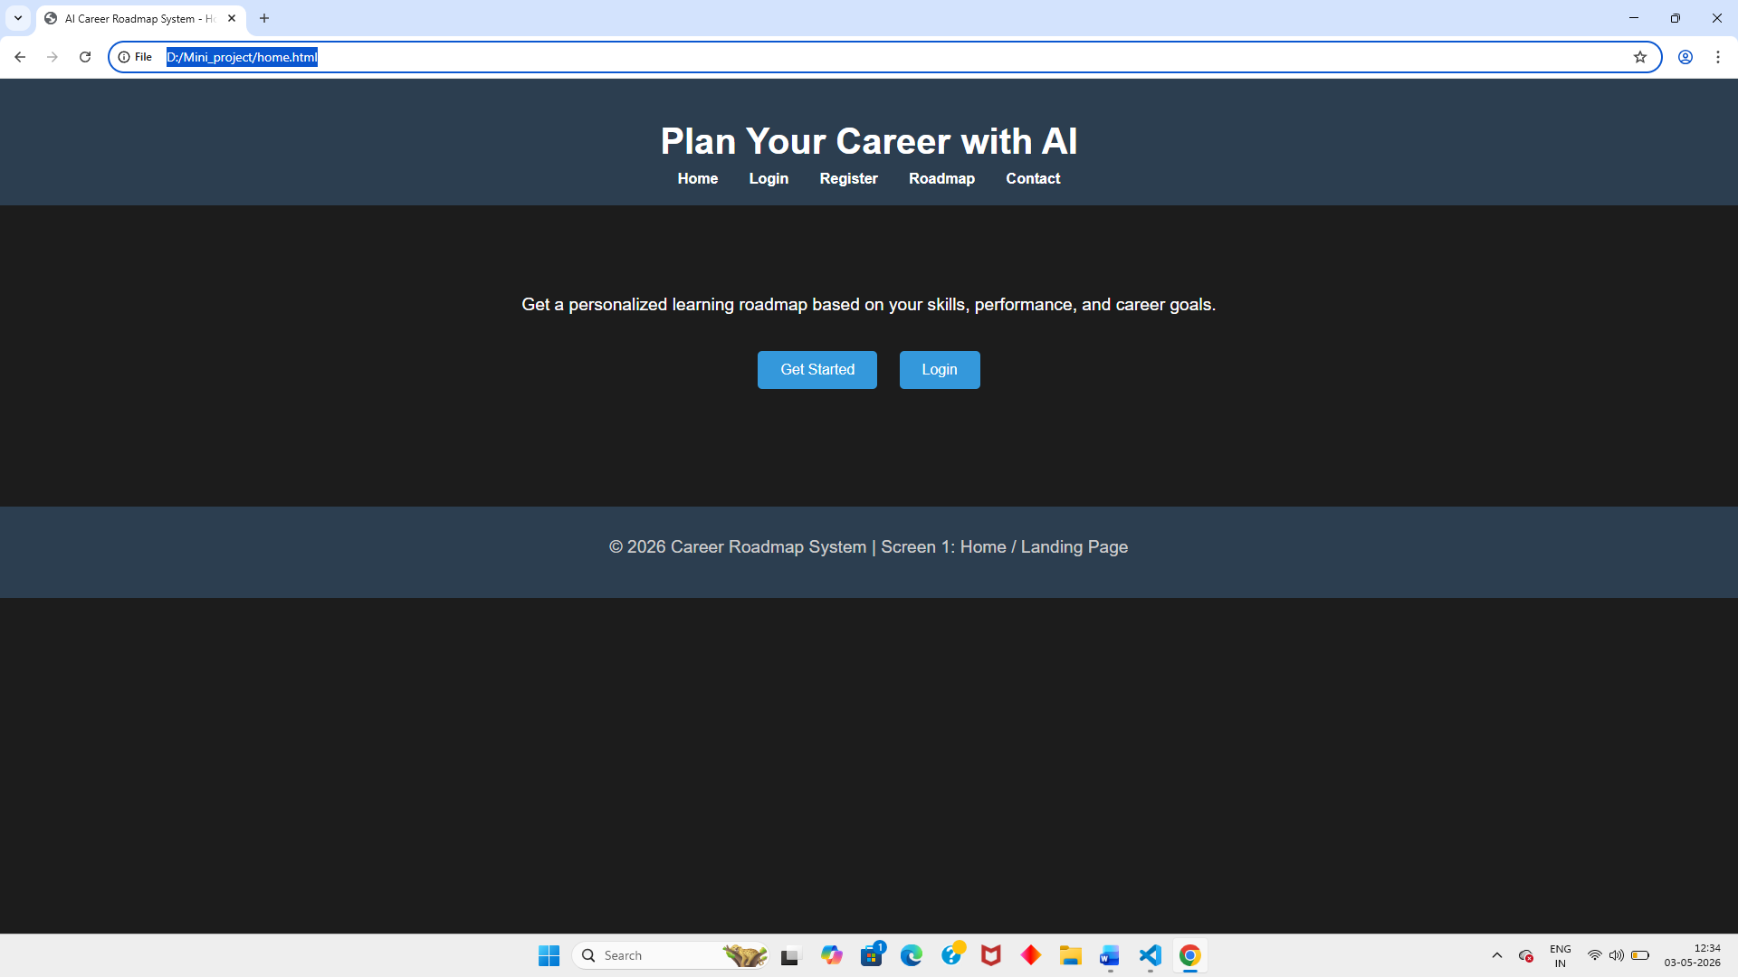
Fig 1

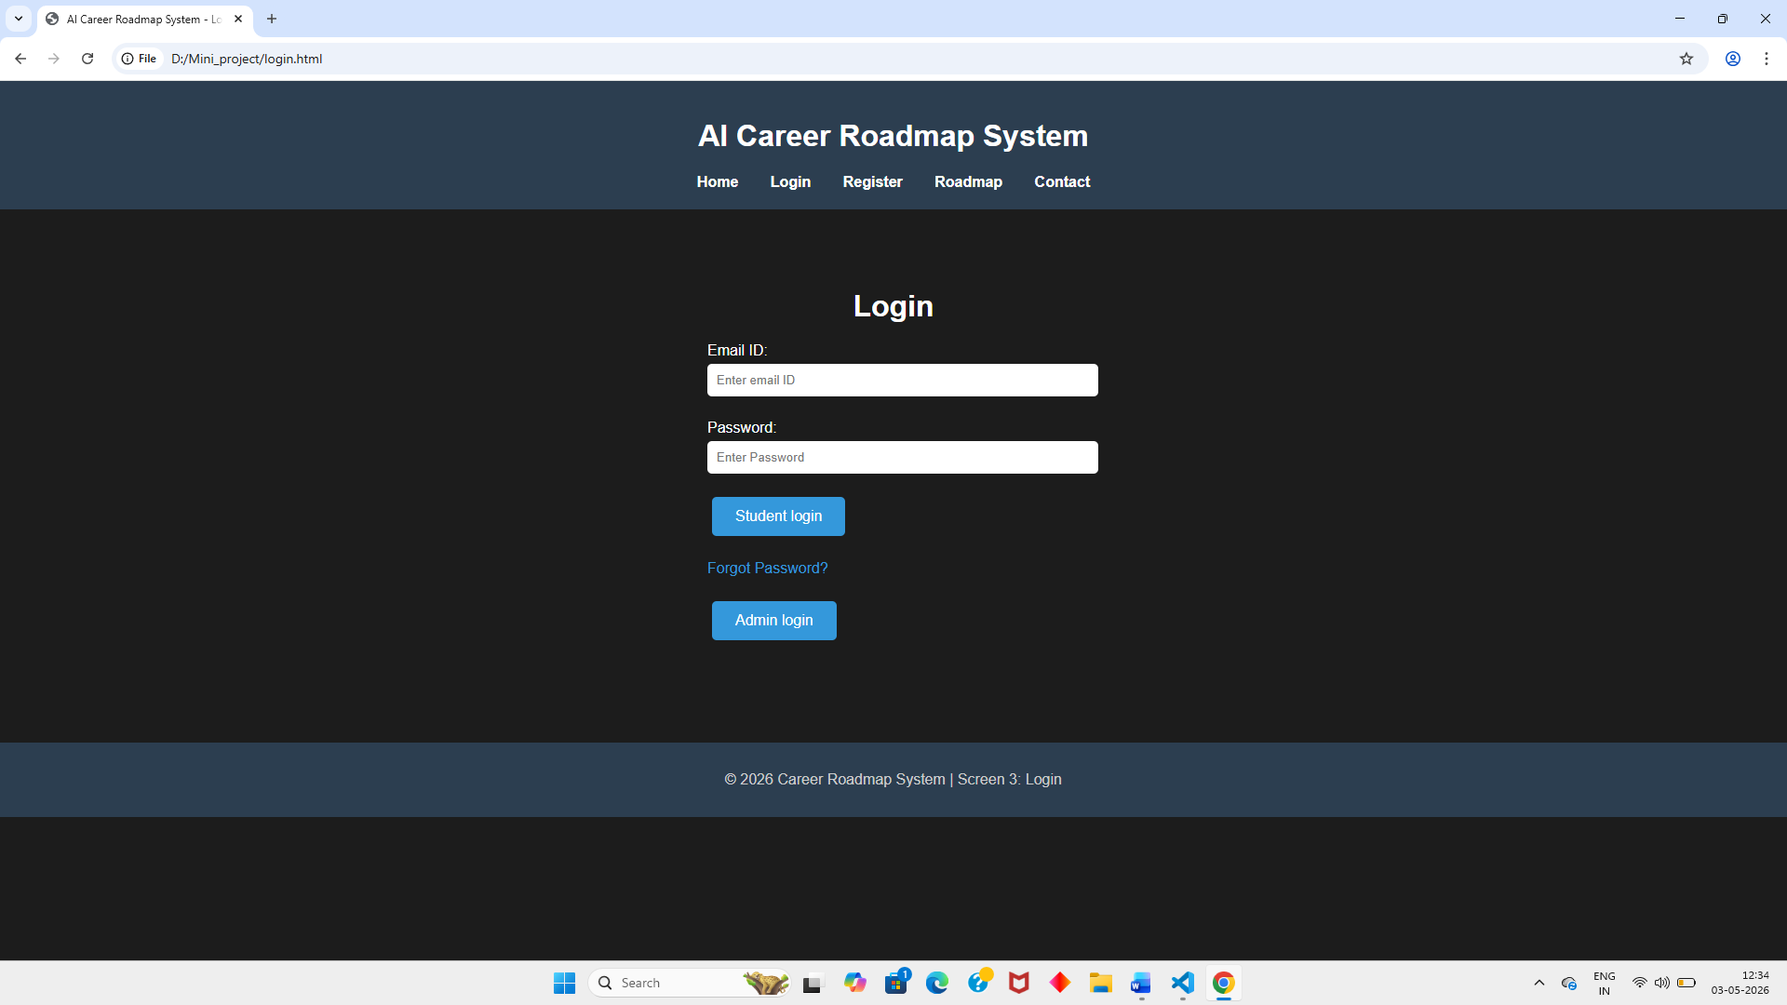

Fig 2

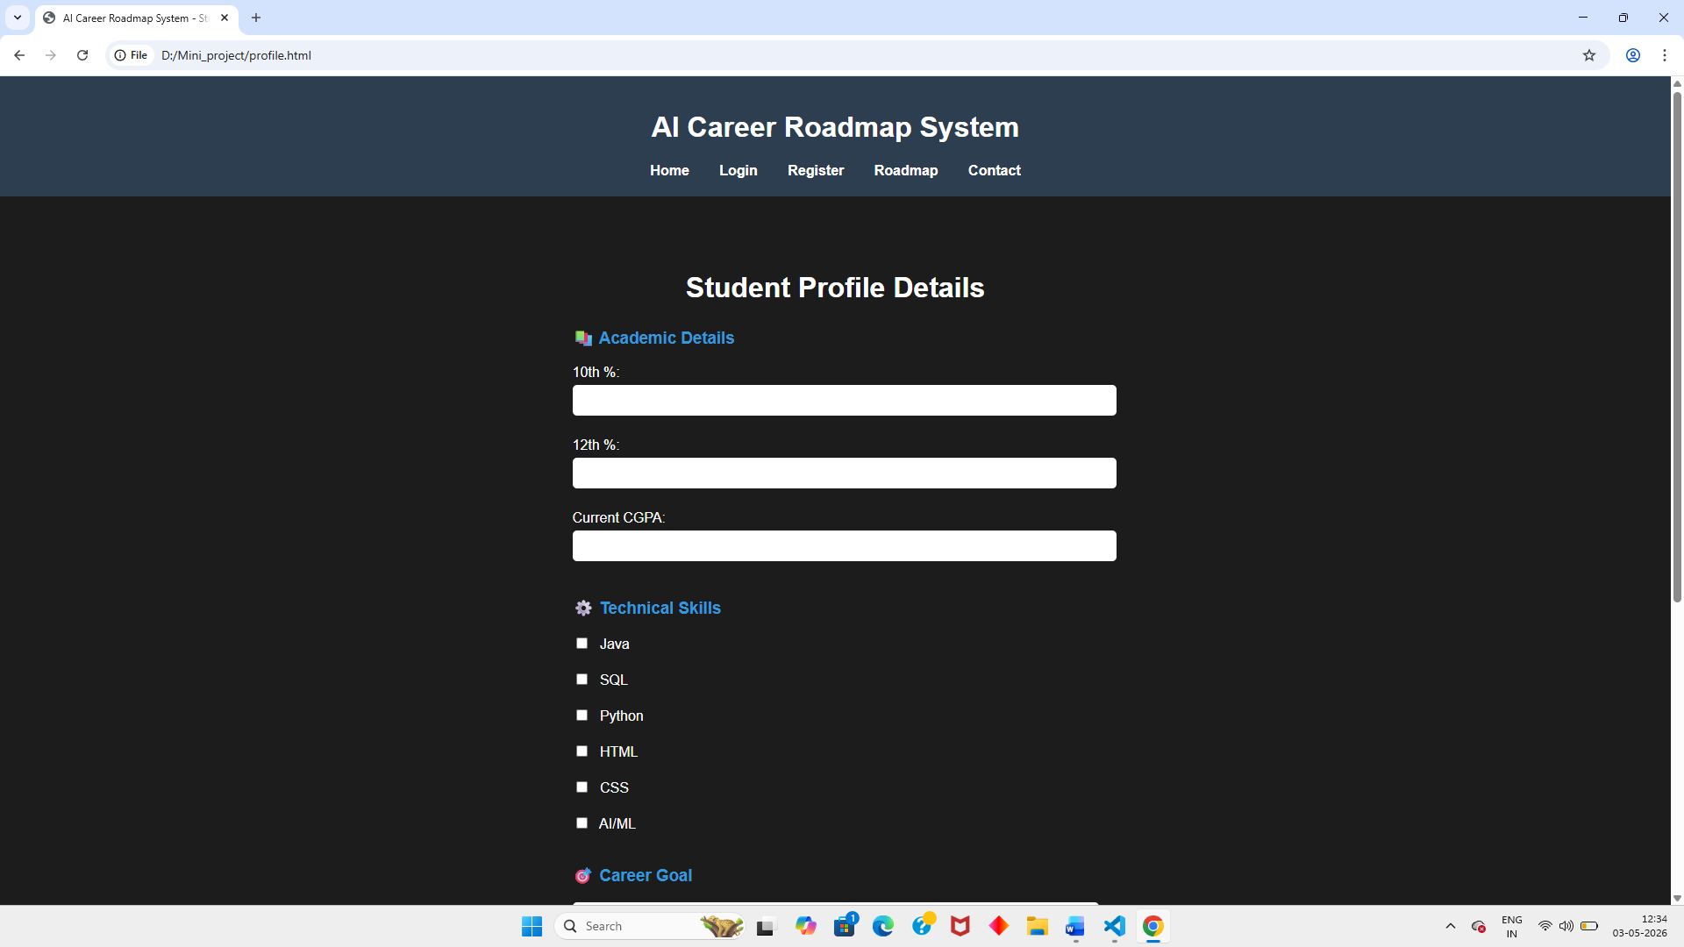
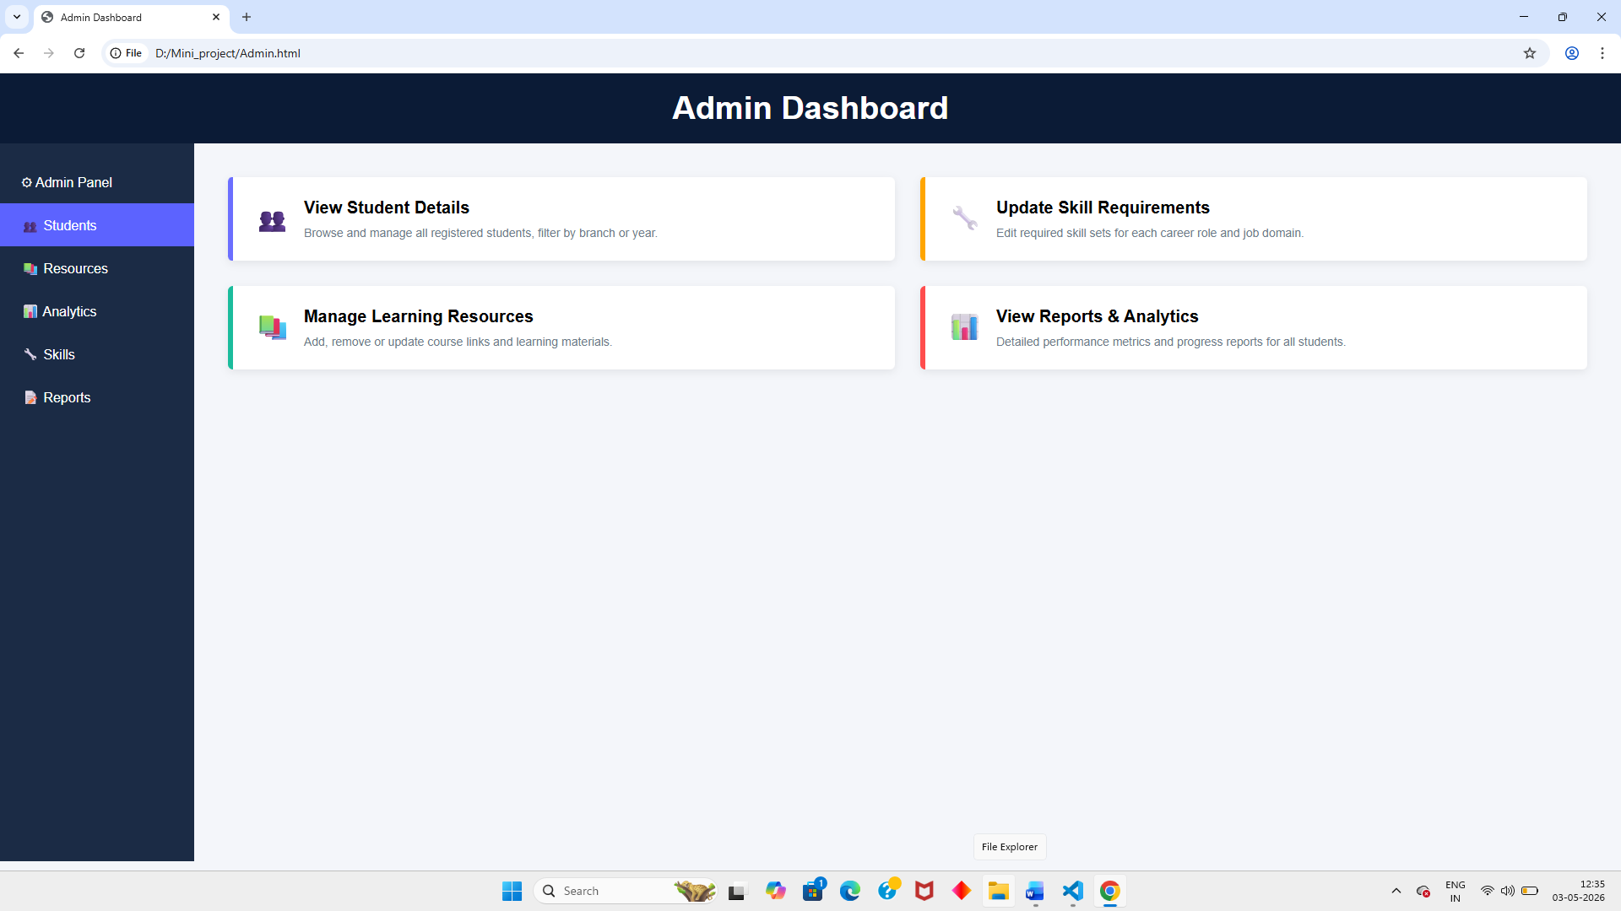

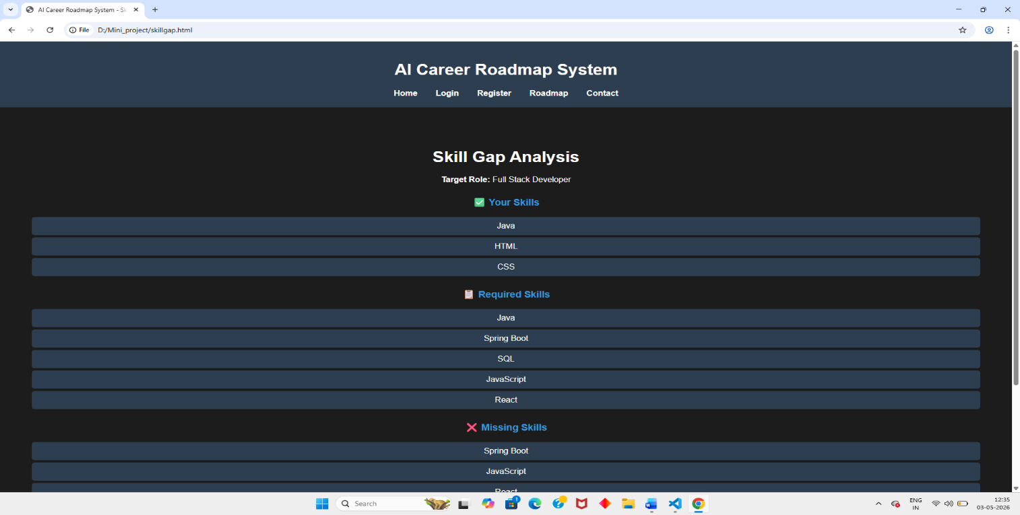

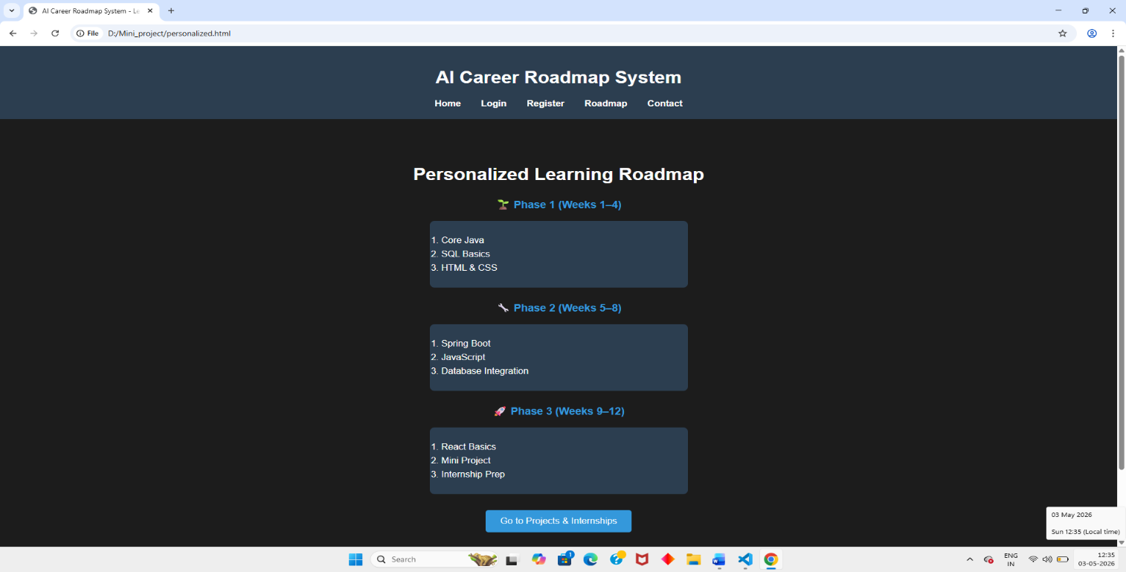

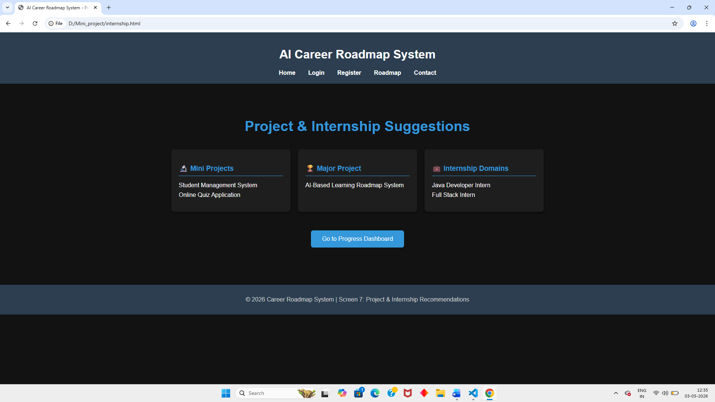
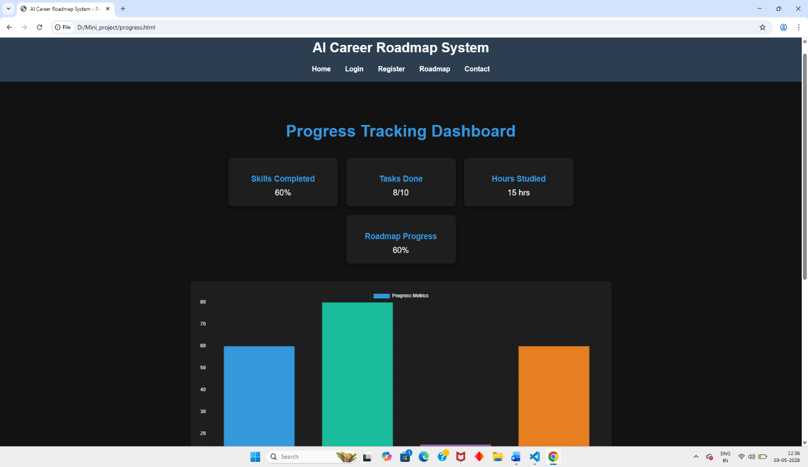
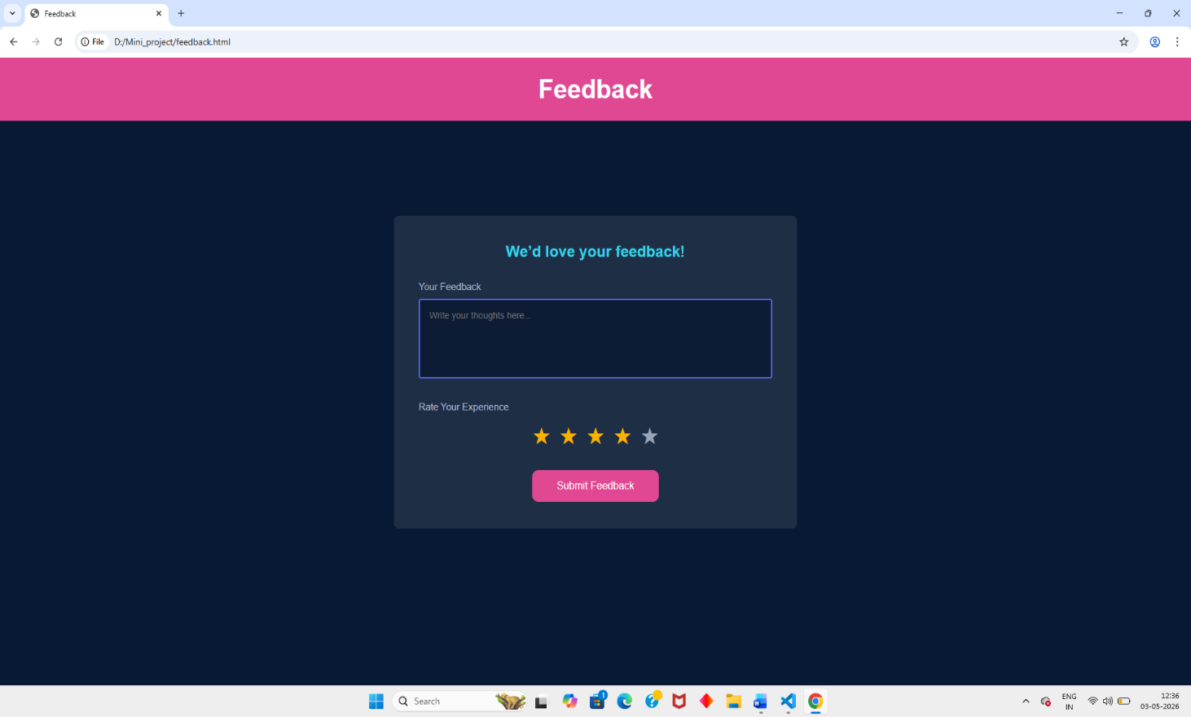

CHAPTER 7

CONCLUSIONS AND FUTURE WORK

7.1 Conclusions
The AI-Based Personalized Learning & Career Roadmap System addresses one of the most pressing and underserved needs in modern engineering education: the absence of intelligent, personalized, and adaptive career guidance for individual students. By leveraging machine learning-based skill gap analysis, hybrid recommendation techniques, and graph-based roadmap generation, the proposed system offers an integrated, practical, and scalable solution that evolves dynamically with each student's progress.

The system moves beyond the limitations of generic career counselling by providing a data-driven, quantitative analysis of each student's current skill profile relative to their chosen career goal, and translating that analysis into a structured, achievable, and continuously updated learning roadmap. The use of well-established algorithms — TF-IDF cosine similarity, KNN collaborative filtering, and Dijkstra's graph traversal — ensures both computational efficiency and proven effectiveness.

The expected outcomes of the system include improved career readiness among students, reduced skill-industry mismatch, more informed academic decision-making, and a demonstrable improvement in the speed of skill acquisition when students follow a structured, personalized plan. The system has strong potential to be adopted at scale across engineering institutions to supplement and enhance existing academic mentorship programmes.

7.2 Future Work (Phase II Plan)
The following enhancements are planned for Phase II of the project:
- Integration of Transformer-Based NLP Models: Incorporate BERT or sentence-transformer models for more precise skill extraction from resumes, job descriptions, and LinkedIn profiles, enabling richer and more accurate skill gap quantification.
- Real-Time Industry Trend Monitoring: Develop an automated web scraping pipeline to continuously collect job posting data from platforms such as LinkedIn, Naukri, and Indeed, and dynamically update the career skill requirement database to reflect evolving industry demands.
- Mobile Application: Build native iOS and Android apps for on-the-go roadmap access, push notification reminders for learning milestones, and offline progress tracking.
- Gamification and Engagement Mechanics: Introduce achievement badges, streak tracking, leaderboards, and peer comparison features to increase student motivation and adherence to the learning roadmap.
- Institutional Analytics Dashboard: Provide department administrators and faculty with aggregated insights into batch-wide skill gaps, career interest distributions, and programme-level improvement recommendations to support curriculum redesign.
- Multi-Domain Expansion: Extend the career skill database beyond technology domains to include management, design, finance, and interdisciplinary career paths.
- Cloud Deployment and Scalability: Deploy the system on AWS or Google Cloud with containerization (Docker) and auto-scaling to support institution-wide adoption for thousands of concurrent users.

REFERENCES

[1] | Drachsler, H., Verbert, K., Santos, O. C., & Manouselis, N. (2015). Panorama of recommender systems to support learning. In Recommender Systems Handbook (pp. 421-451). Springer, Boston, MA.
[2] | Pejic, A., Barisic, A., & Pavlic, L. (2020). AI-based skill gap analysis using NLP and job market data. International Conference on Computer Science and Education, 220-228.
[3] | Al-Otaibi, S. T., & Ykhlef, M. (2012). A survey of job recommender systems. International Journal of Physical Sciences, 7(29), 5127-5142.
[4] | Vandewaetere, M., Desmet, P., & Clarebout, G. (2011). The contribution of learner characteristics in the development of computer-based adaptive learning environments. Computers in Human Behavior, 27(1), 118-130.
[5] | Chen, P., Lu, Y., Zheng, V. W., & Pian, Y. (2018). KnowEdu: A system to construct knowledge graph for education. IEEE Access, 6, 31553-31563.
[6] | Chung, J., & Lee, S. (2019). Dropout early warning systems for high school students using machine learning. Children and Youth Services Review, 96, 346-353.
[7] | Koren, Y., Bell, R., & Volinsky, C. (2009). Matrix factorization techniques for recommender systems. Computer, 42(8), 30-37.
[8] | Onah, D. F. O., Sinclair, J., & Boyatt, R. (2014). Dropout rates of massive open online courses: Behavioral patterns. Proceedings of EDULEARN14, 5825-5834.
[9] | Devlin, J., Chang, M. W., Lee, K., & Toutanova, K. (2019). BERT: Pre-training of deep bidirectional transformers for language understanding. Proceedings of NAACL-HLT, 4171-4186.
[10] | Hu, Q., & Rangwala, H. (2020). Academic performance estimation with attention-based graph convolutional networks. ACM Transactions on Intelligent Systems and Technology, 11(5), 1-23.
[11] | Verbert, K., Manouselis, N., Ochoa, X., et al. (2012). Context-aware recommender systems for learning. IEEE Transactions on Learning Technologies, 5(4), 318-335.
[12] | Polyzou, A., & Karypis, G. (2019). Feature extraction for next-term prediction of poor student performance. IEEE Transactions on Learning Technologies, 12(2), 237-248.
[13] | Liu, M., McKelroy, E., Corliss, S. B., & Carrigan, J. (2017). Investigating the effect of an adaptive learning intervention on students' learning. Educational
[14] | Kloft, M., Stiehler, F., Zheng, Z., & Pinkwart, N. (2014). Predicting MOOC dropout over weeks using machine learning methods. EMNLP Workshop on Analysis of Large Scale Social Interaction in MOOCs, 60-65.
[15] | Bhaskaran, S., & Santhi, B. (2019). An efficient personalized trust-based hybrid recommendation system for e-learning. Computers in Human Behavior, 90, 192-204.
[16] | Jiang, W., Pardos, Z. A., & Wei, Q. (2019). Goal-based course recommendation. Proceedings of the 9th International Conference on Learning Analytics & Knowledge, 36-45.
[17] | Wang, D., & Zhu, H. (2020). Career path prediction using resume representation learning with external knowledge base enrichment. Proceedings of AAAI, 34(1), 965-972.
[18] | Agrawal, R., & Srikant, R. (2014). Fast algorithms for mining association rules in large databases. Proceedings of the VLDB Conference, 487-499.
[19] | Nguyen, T., & Dung, P. (2021). An adaptive e-learning system using machine learning to personalize course recommendations. Journal of Educational Technology Systems, 50(2), 119-143.
[20] | Zhang, Y., Chen, X., & Zhao, Z. (2022). Graph neural networks for personalized learning path recommendation. IEEE Transactions on Knowledge and Data Engineering, 34(8), 3694-3707.

